BLACKBOX TESTING

Members: Anshuman Singh

Rajat Singh

Anshul Sharma

Roshan Dibya Ranjan

Mihir Sharma

Shefali Gill

**Login Page**: 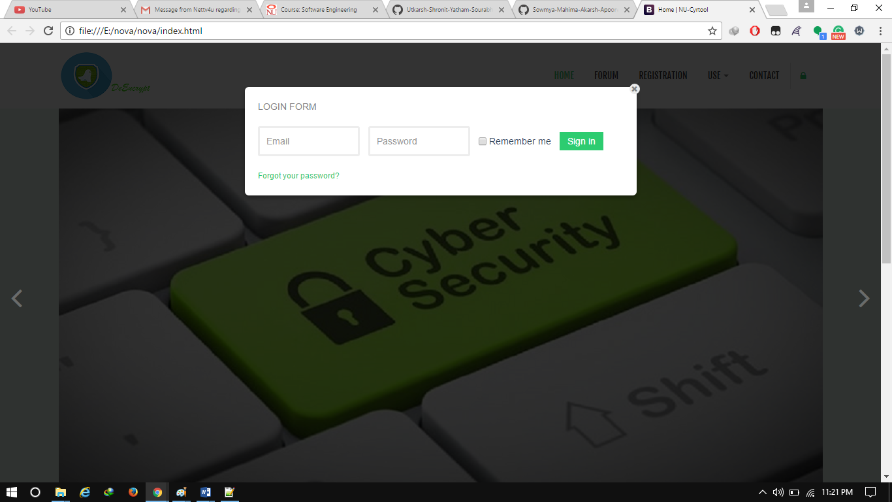

**Positive Scenario**

**Inputs**: Valid Username and Password

**Desired Outputs**: Redirected to Appropriate Pages after login, user can access various features like learn and use which are main feature of this WebApp.

**Actual Output**: The website redirects to the correct pages

**Negative Scenario**: Invalid Credentials

**Input**: Wrong Username and Password

**Desired Output**: Redirected to the login page again and give message invalid input

**Actual output**: redirected To Login Page again

**TEST CASE STATE:** Successful

**Home page**

**Desired output:** Home page.

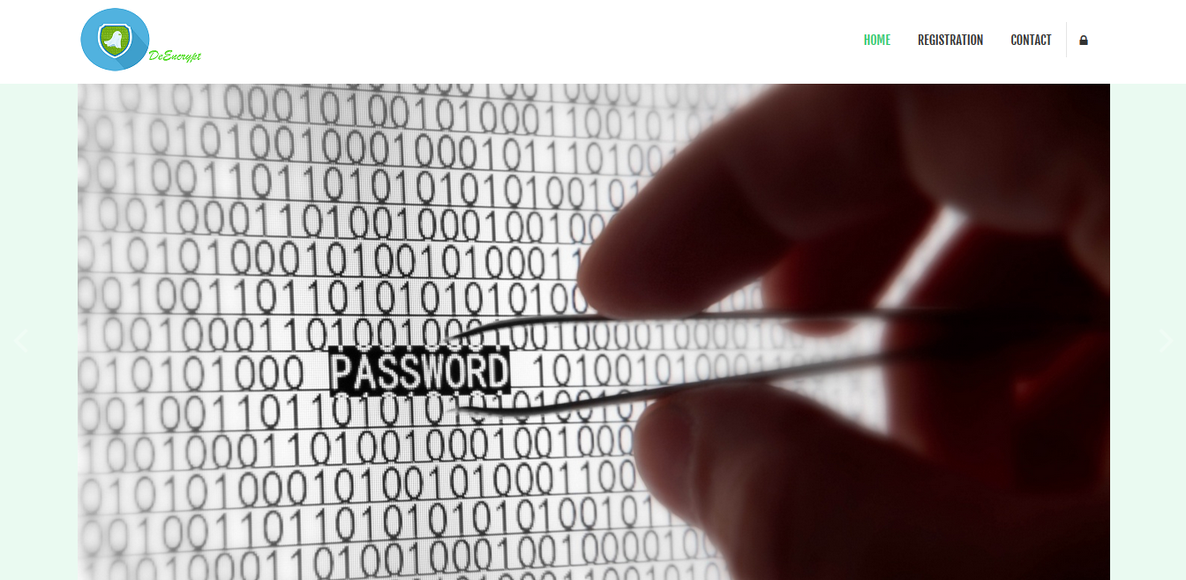

**Actual Output:** Home page with introduction.

**Forum**

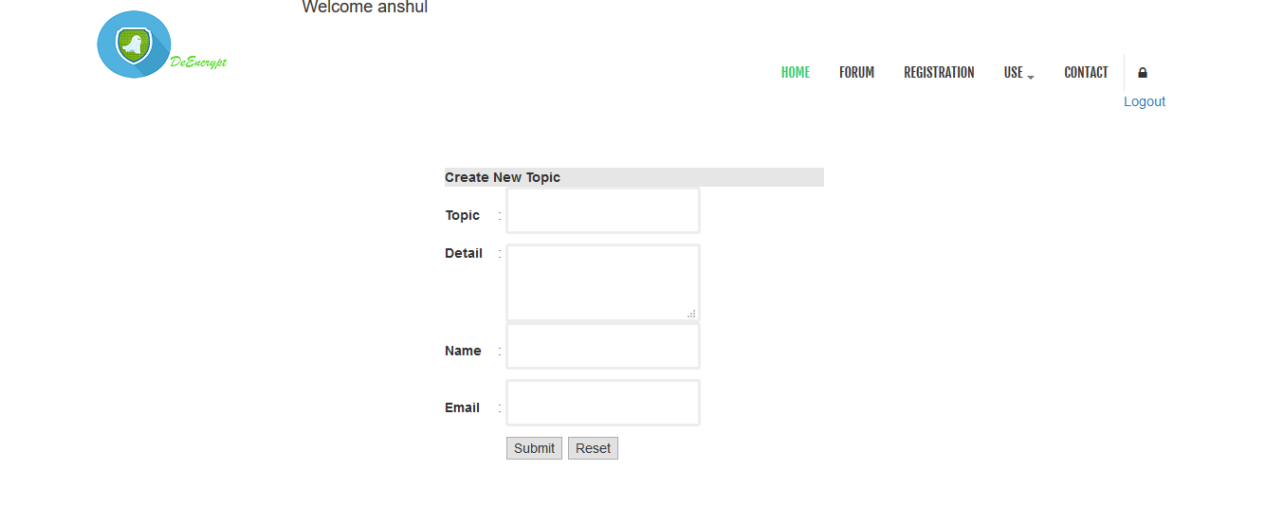

**Input**: Enter queries

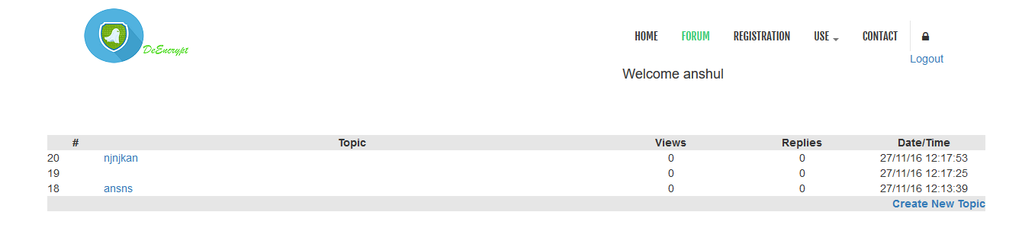

**Desired Output**: answer to the queries.

**Registration**

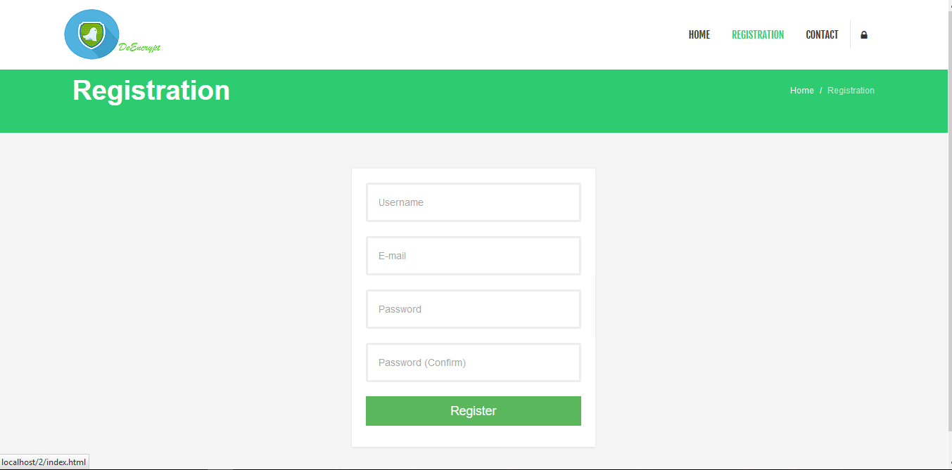

**Input**: You can register here if you are a new user.

**Desired Output**: You can now access learn and use page which will help to learn and use of various encryption and decryption page.

**USE:** You can use various algorithm for the decryption and encryption 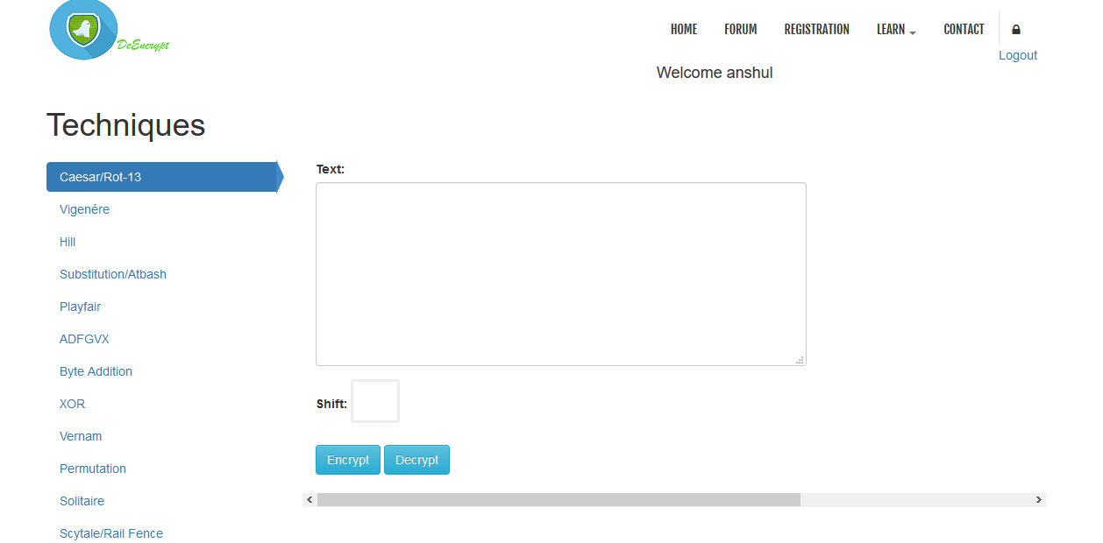

**Learn:** you can learn here various algorithm.

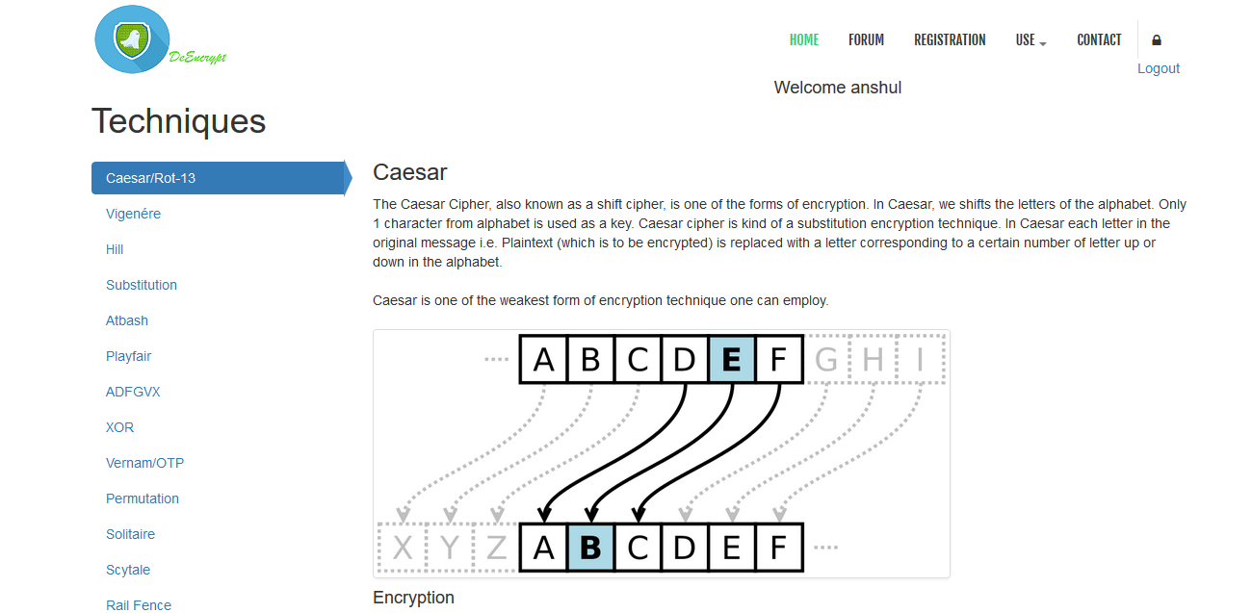

**Contact:**

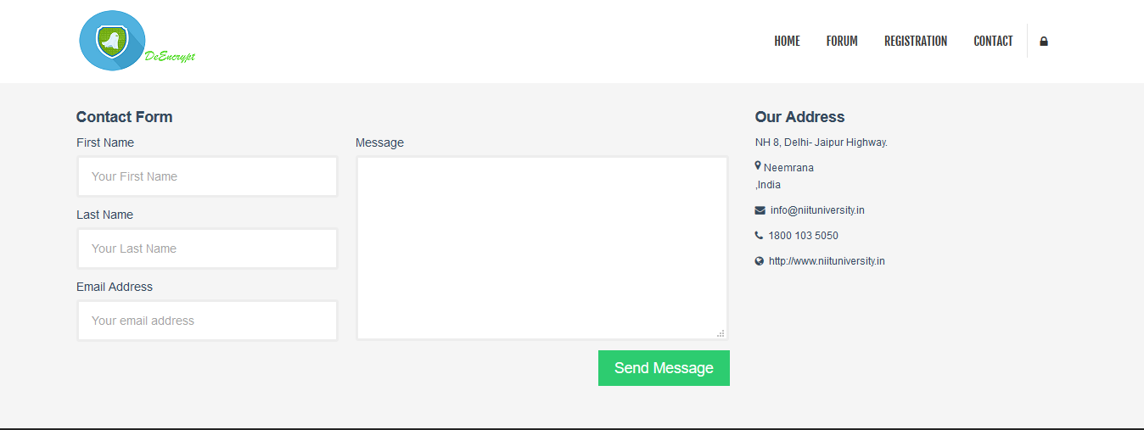

**Input**: Enter your detail and message

**Output:** Admin will revert back to you as soon as possible.